CS3840 Computer Security Homework 4 2017

Name:

1. For the DAC model discussed in Section 4.3, an alternative representation of the protection state is a directed graph. Each subject and each object in the protection state is represented by a node (a single node is used for an entity that is both subject and object). A directed line from a subject to an object indicates an access right, and the label on the link defines the access right.

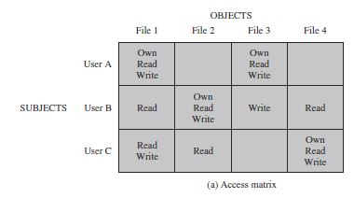

* 1. Draw a directed graph that corresponds to the access matrix of above figure.



* 1. Is there a one-to-one correspondence between the directed graph representation and the access matrix representation? Explain.

Yes there is a correspondence between the two. They both are showing the same information for each user, just in a different way.

1. Figure below shows a sequence of grant operations for a specific access right on a table. Assume that at *t* = 70, B revokes the access right from C. Using the conventions defined in Section 5.4, show the resulting diagram of access right dependencies.

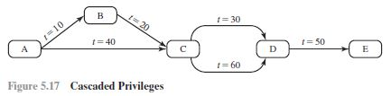

B

E

D

C

A

B would still have the right from A. C would have the right revoked from B, but it also got it from A at time 40. C could still give D the right at time 60. E would not be able to get the right from D, unless it was after time 60.

1. Suppose you observe that your home PC is responding very slowly to information requests from the net. And then you further observe that your network gateway shows high levels of network activity, even though you have closed your e-mail client, Web browser, and other programs that access the net.
2. What types of malware could cause these symptoms?

Viruses, worms, spyware, Trojan Horse

1. Discuss how the malware might have gained access to your system.

Malware can gain access to your system in different ways. One would be clicking an attachment in an Email, which is fake and infected. Another way this could gain access would be any torrenting of things from the Internet. Many of these files can have malware attached to them. Once downloaded, the malware can have access to your system.

1. What steps can you take to check whether this has occurred?

You could have an antivirus program scan your system for malware. Executable files can be run through a Generic Decryption scanner.

1. If you do identify malware on your PC, how can you restore it to safe operation?

Start your PC up in SafeMode, then delete all the temporary files. Next, use a malware scanner to find any malware on the PC. This can then remove these from the PC.